Crud operations
Java
CRUD_test.java:
package newthing;

import java.sql.Connection;
import java.sql.PreparedStatement;
import java.sql.ResultSet;

public class CRUD_Test {

public static void main(String[] args) {

CRUD_Test objTest = new CRUD_Test();

// Insert data
objTest.create_data("1", "jinu", "jinu@gmail.com");
objTest.create_data("2", "jawad", "jawad@gmail.com");

// Read data
objTest.read_data();

// Update data
objTest.update_data("2", "22", "jawad2", "jawad2@gmail.com");

// Delete data
objTest.delete_data("1");
}

public void create_data(String sl_no, String name, String email) {

DB_CONNECTION obj_DB_Connection = new DB_CONNECTION();
Connection connection = obj_DB_Connection.get_connection();

try {
String query =
"INSERT INTO user(sl_no, name, email) VALUES (?, ?, ?)";

PreparedStatement ps =
connection.prepareStatement(query);

ps.setString(1, sl_no);
ps.setString(2, name);
ps.setString(3, email);

int rows = ps.executeUpdate();

System.out.println(rows + " row inserted");
} catch (Exception e) {
e.printStackTrace();
}
}

public void read_data() {

DB_CONNECTION obj_DB_Connection = new DB_CONNECTION();
Connection connection = obj_DB_Connection.get_connection();

try {
String query = "SELECT * FROM user";

PreparedStatement ps =
connection.prepareStatement(query);

ResultSet rs = ps.executeQuery();

while (rs.next()) {

System.out.println(
rs.getString("sl_no") + " | " +
rs.getString("name") + " | " +
rs.getString("email"));
}

} catch (Exception e) {
e.printStackTrace();
}
}

public void update_data(String sl_no,
String new_sl_no,
String name,
String email) {

DB_CONNECTION obj_DB_Connection = new DB_CONNECTION();
Connection connection = obj_DB_Connection.get_connection();

try {

String query =
"UPDATE user SET sl_no=?, name=?, email=? WHERE sl_no=?";

PreparedStatement ps =
connection.prepareStatement(query);

ps.setString(1, new_sl_no);
ps.setString(2, name);
ps.setString(3, email);
ps.setString(4, sl_no);

int rows = ps.executeUpdate();

System.out.println(rows + " row updated");

} catch (Exception e) {
e.printStackTrace();
}
}

public void delete_data(String sl_no) {

DB_CONNECTION obj_DB_Connection = new DB_CONNECTION();
Connection connection = obj_DB_Connection.get_connection();

try {

String query =
"DELETE FROM user WHERE sl_no=?";

PreparedStatement ps =
connection.prepareStatement(query);

ps.setString(1, sl_no);

int rows = ps.executeUpdate();

System.out.println(rows + " row deleted");

} catch (Exception e) {
e.printStackTrace();
}
}
}
DB_CONNECTION.java:
package newthing;

import java.sql.Connection;
import java.sql.DriverManager;

public class DB_CONNECTION {

public static void main(String[] args) {
DB_CONNECTION obj_DB_Connection = new DB_CONNECTION();
System.out.println(obj_DB_Connection.get_connection());
}

public Connection get_connection() {
Connection connection = null;

try {
Class.forName("com.mysql.cj.jdbc.Driver");

connection = DriverManager.getConnection(
"jdbc:mysql://localhost:3306/test",
"root",
"root");
} catch (Exception e) {
e.printStackTrace();
}

return connection;
}
}
OUTPUT:
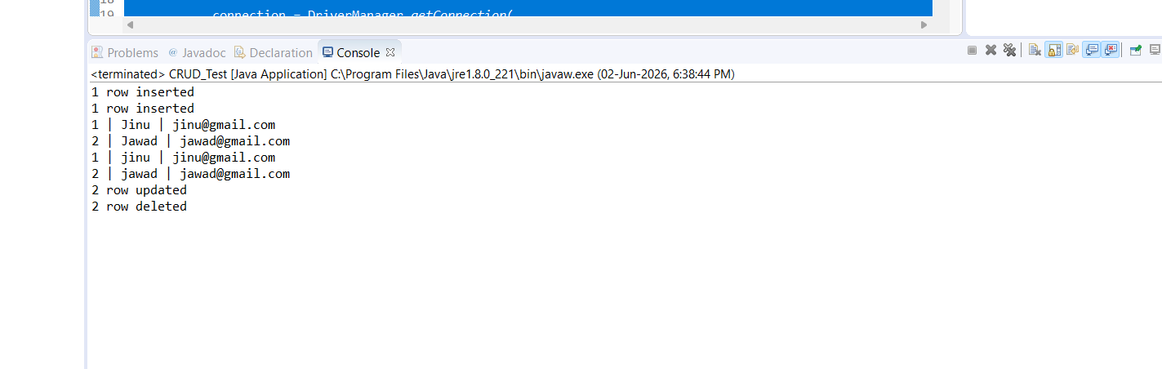
Edit crud code:
public void edit_data(String sl_no){
DB_Connection obj_DB_Connection=new DB_Connection();
Connection connection=obj_DB_Connection.get_connection();
PreparedStatement ps=null;
ResultSet rs=null;
try{
String query = "select * from user where sl_no=?";
ps = connection.prepareStatement(query);
ps.setString(1, sl_no);
System.out.println(ps);
rs=ps.executeQuery();
if(rs.next()){
System.out.println("Sl no -"+rs.getString("sl_no"));
System.out.println("name -"+rs.getString("name"));
System.out.println("email -"+rs.getString("email"));
System.out.println("---------------");
}
}catch (Exception e) {
System.out.println(e);
}
}
OUTPUT:
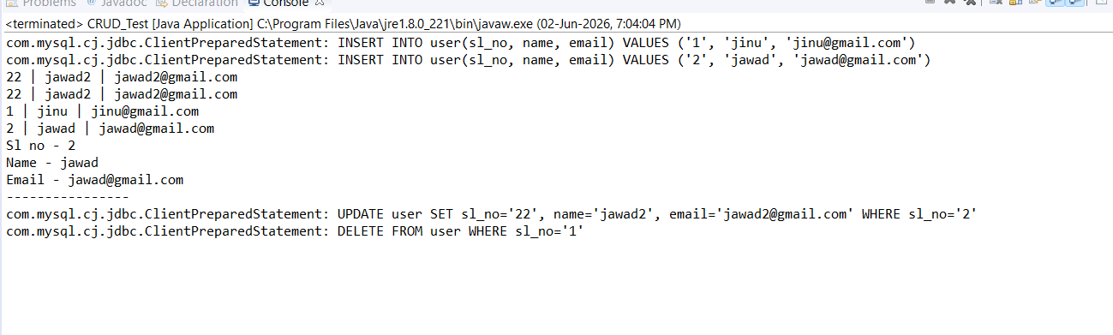
Truncate and alter:
Code:
package newthing;

import java.sql.Connection;
import java.sql.PreparedStatement;

public class CRUD_Test {

public static void main(String[] args) {

CRUD_Test objTest = new CRUD_Test();

// Add a new column to student table
objTest.alter_table();

// Delete all records from student table
objTest.truncate_data();
}

// ALTER TABLE
public void alter_table() {

DB_CONNECTION obj_DB_Connection = new DB_CONNECTION();
Connection connection = obj_DB_Connection.get_connection();

try {

String query =
"ALTER TABLE student ADD address VARCHAR(20)";

PreparedStatement ps =
connection.prepareStatement(query);

System.out.println(ps);

ps.executeUpdate();

System.out.println("Column added successfully.");

} catch (Exception e) {
e.printStackTrace();
}
}

// TRUNCATE TABLE
public void truncate_data() {

DB_CONNECTION obj_DB_Connection = new DB_CONNECTION();
Connection connection = obj_DB_Connection.get_connection();

try {

String query =
"TRUNCATE TABLE student";

PreparedStatement ps =
connection.prepareStatement(query);

System.out.println(ps);

ps.executeUpdate();

System.out.println("All records deleted successfully.");

} catch (Exception e) {
e.printStackTrace();
}
}
}
OUTPUT:
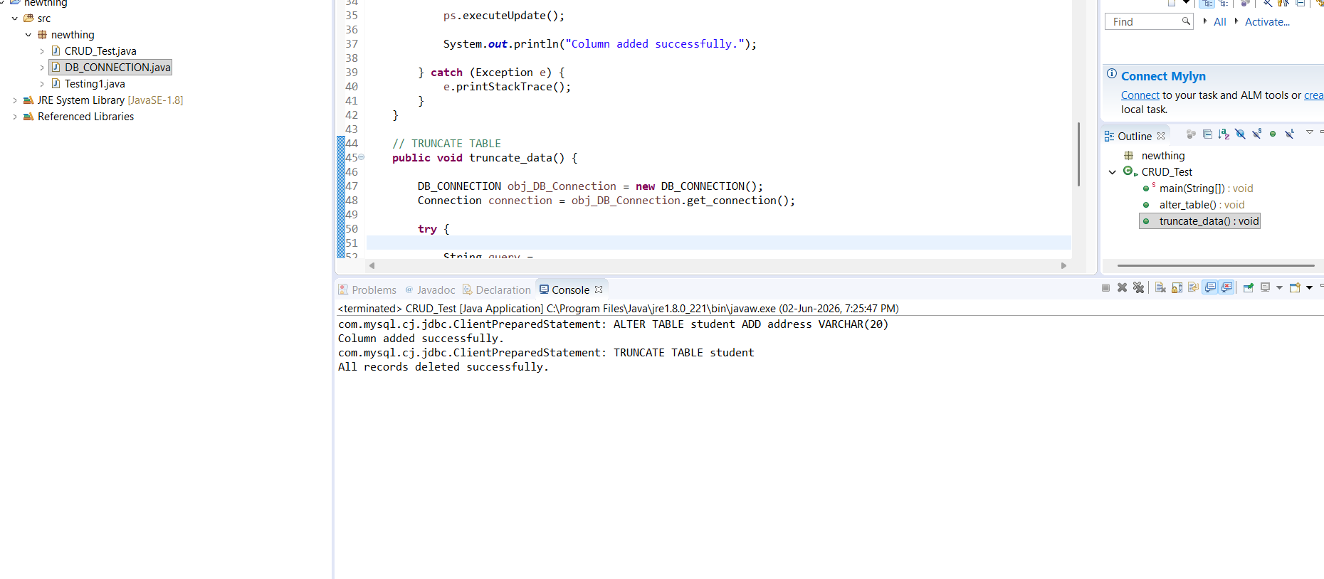
MONGO DB CONNECTIVITY:
Code:
package anotherNewProject;

import com.mongodb.client.MongoClient;
import com.mongodb.client.MongoClients;
import com.mongodb.client.MongoDatabase;

public class MongoDBConnection {
public static void main(String[] args) {
String connectionString = "mongodb://localhost:27017";

try (MongoClient mongoClient = MongoClients.create(connectionString)) {
MongoDatabase database = mongoClient.getDatabase("testdb");
System.out.println("Connected successfully to MongoDB!");
}
}
}
OUTPUT:
